Practice Exercises

- Customer Purchase Summary Report
You have received transaction data from customer purchases at electronic store as given below:
transactions = [
{"customer": "Alex", "product": "Laptop", "amount": 1200},
{"customer": "Jay", "product": "Mouse", "amount": 25},
{"customer": "Jammie", "product": "Headphones", "amount": 150},
{"customer": "Alex", "product": "Keyboard", "amount": 75},
{"customer": "Jammie", "product": "Monitor", "amount": 300},
]
You need to calculate the total amount spent by each customer and display the result in a clean format.
Expected Output: The output should look like
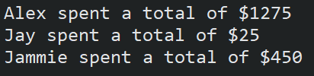

- Stock Portfolio Tracker
You are an investor and your current stock holdings are given below:

portfolio = {
"AAPL": {"shares": 10, "price": 1250.3},
"GOOGL": {"shares": 5, "price": 2800.5},
"TSLA": {"shares": 8, "price": 190.1}
}

To compute current portfolio value, follow these steps:
Step 1: Multiply share counts and price for each stock
Step 2: Calculate the total value of the portfolio and print the individual stock values too
[Hint: Use a for loop to iterate over portfolio dictionary.]

The objective of these exercises is to demonstrate how for loop can be used to iterate over given iertable.

